System Dashboard

Table of contents

* [Video walkthrough](javascript:;)
* [Filters](javascript:;)
* [Map](javascript:;)
* [Details grid](javascript:;)
* [Free format messages](javascript:;)

**Video walkthrough**

**The Flow analytics dashboard can give you insights such as**

1. What your volume was in a specific time period
2. What amounts were transacted between branches
3. Which clients transacted in a specific geography
4. How many transactions were high risk

– and many more details and single transaction data via filtering and visual interrogation.

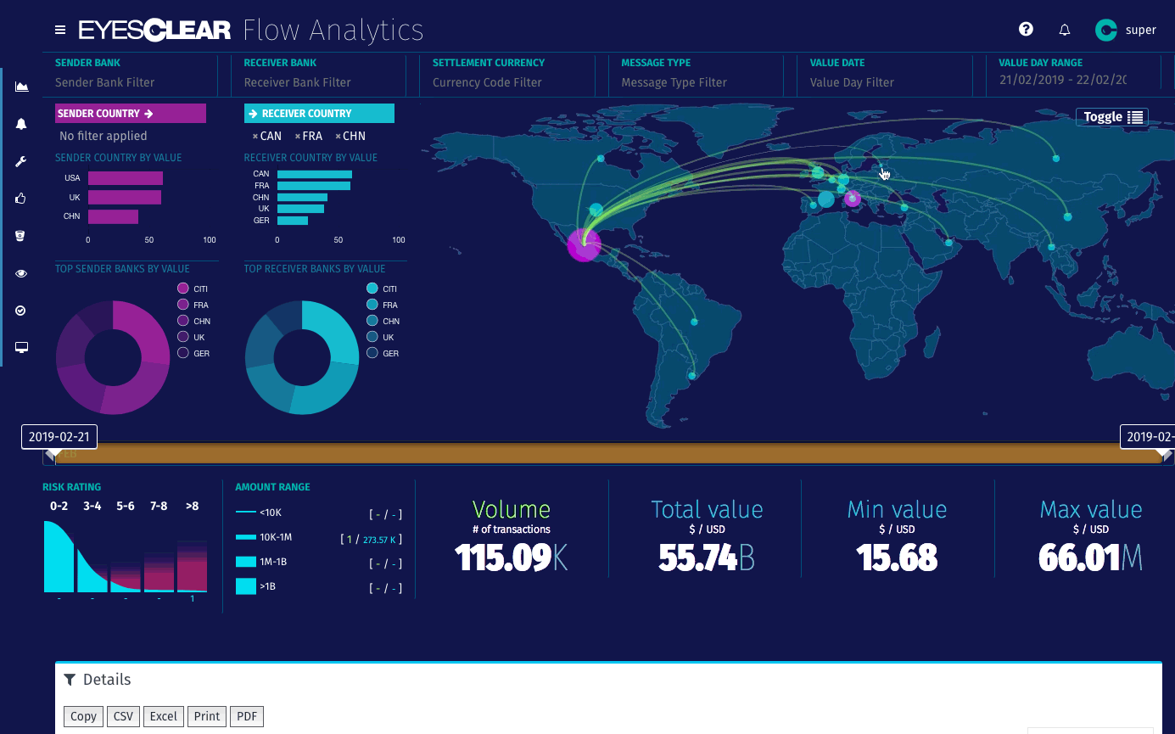

Flow analytics screen

**Filters**

**Sender bank / Receiver bank**

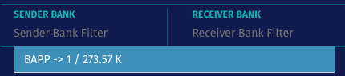

Select sender and receiver banks by Bank code. Each transacting bank is listed with its corresponding Volume and Total value sums.

**Settlement currency**

Filter by transaction currency. Each currency is listed with its corresponding Volume and Total value sums.

**Message type**

Filter by Message types. Each message type is listed with its corresponding Volume and Total value sums.

**Value date**

Filter by Value date. Each value date is listed with its corresponding Volume and Total value sums.

**Value day range**

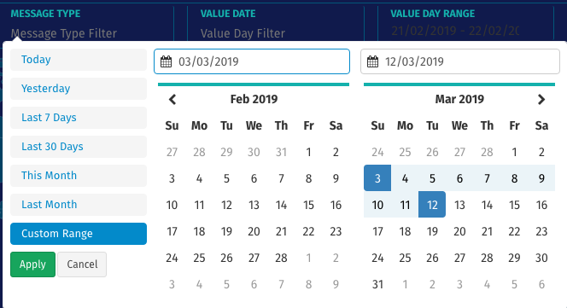

Filter by date range via the date picker from the Value Day Range filter or the Date slider below the map

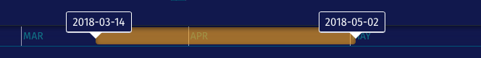

**Risk rating**

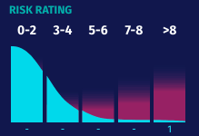

Filter transactions by selecting one or more risk profile step(s)

**Amount range**

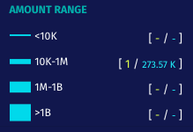

Select one or more range(s) to filter on transactions in that range

**Map**

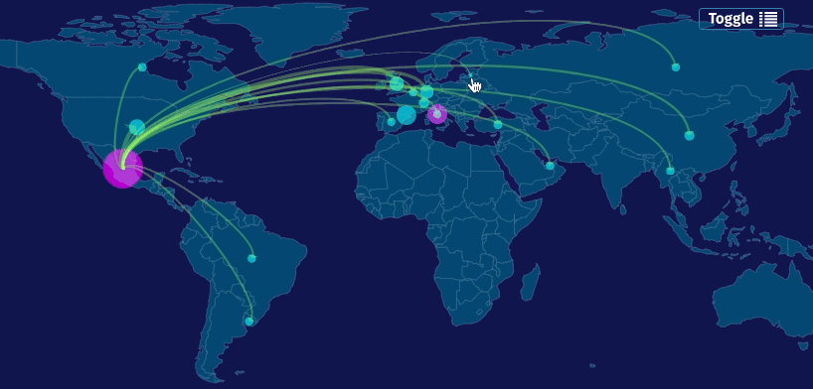

Click on a country to see what transactions were initiated from that country (Set as “Sender country”). If you click on a second country it will be set as “Receiver country”.

The Flow Analytics map gives a visual representation of the transaction flows across geographies. The thickness of the flow lines indicates transaction volume while bubbles on countries indicate total amounts transacted – blue bubbles for received amounts, magenta bubbles for sent amounts.

For a list view of the same data, hit the “Toggle”-button in the top right corner of the map:

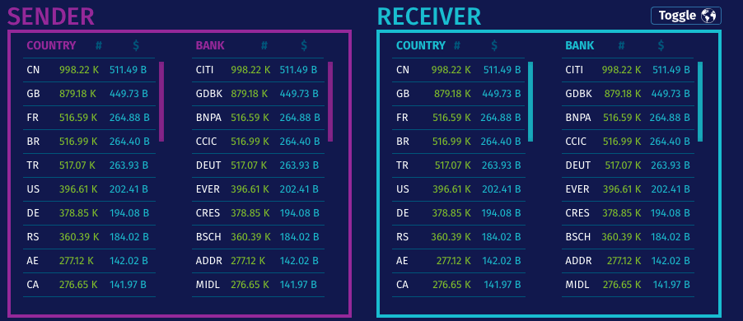

**Details grid**

Interrogate your data further by clicking the “Volume”-tile when you have filtered your data to <10 000 transactions. Eyesclear then downloads the transaction data and populates the details grid. Use the grid to

1. further interrogate data via ultra fast text search on any data field
2. hover over a table line to bring up the original message data.
3. right click to share an insight with a co-worker.

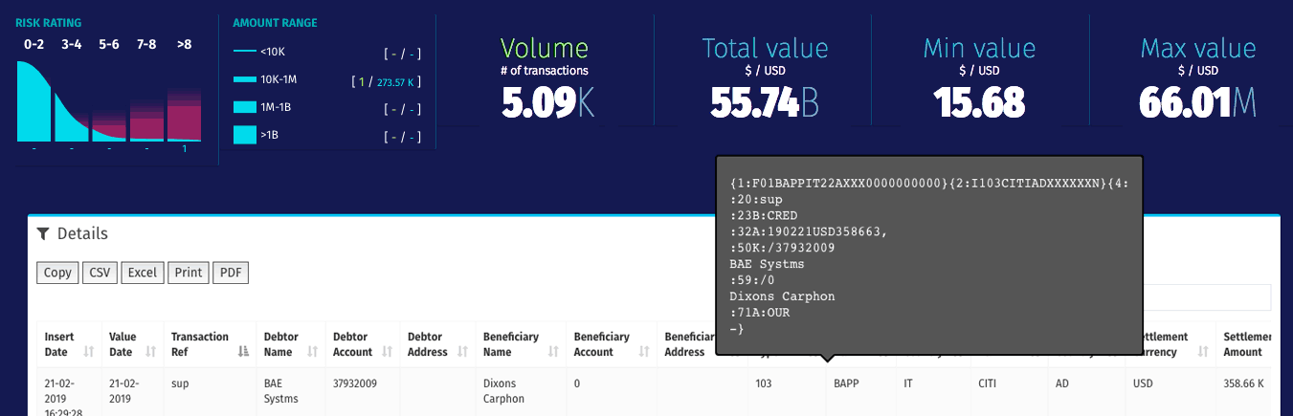

**Free format messages**

Search for Free format messages via the […] panel. This will open a separate dialog, because these messages are independent from the actual transaction file.